Symbolism: Something that stands for something else, and has a greater or deeper meaning. Ex. American flag, red cross, or red light.

Directions: Name what each of the following symbols stands for.
 | 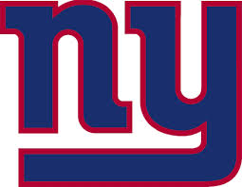 | 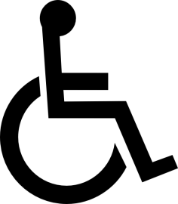

Next, choose one of these symbols, and take some time to think about it. What else does the symbol make you think of? What does it represent? How does it make you feel? In at least four complete sentences, describe what your symbol symbolizes.
__________________________________________________________________________________________________________________________________________________________________________________________________________________________________________________________________________________________________________________________________________________________________________________________________________________________________________________________________________________________________________________________________________________________________
Review: Symbolism
- “Head-Butting the Wall” by Mike Vallely

What does the skateboard symbolize for Mike?

hjygfjytjjythtrshtrs
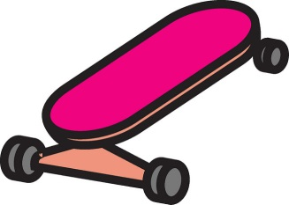

Find a quotation or text evidence to support your answer. _______________________________________________
____________________________________________________________________________________________________________________________________________________________________________________________________________________________________

